− Member1: Use „git status“… what do you see?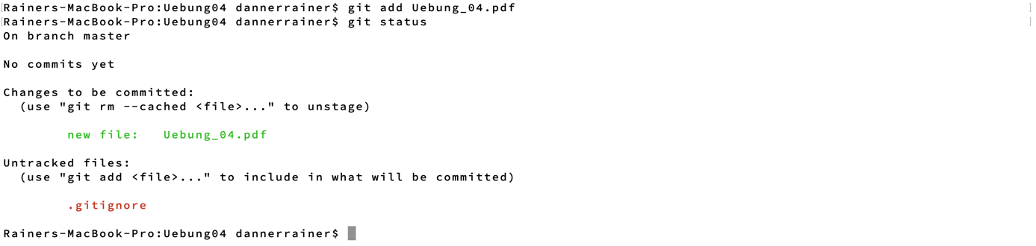

Member2: what is the status? Why does the folder not show as an

untracked file?



Because the folder contains no files which are changed.



After adding files in the folder the folder shows up as not added.

Member1 pull:

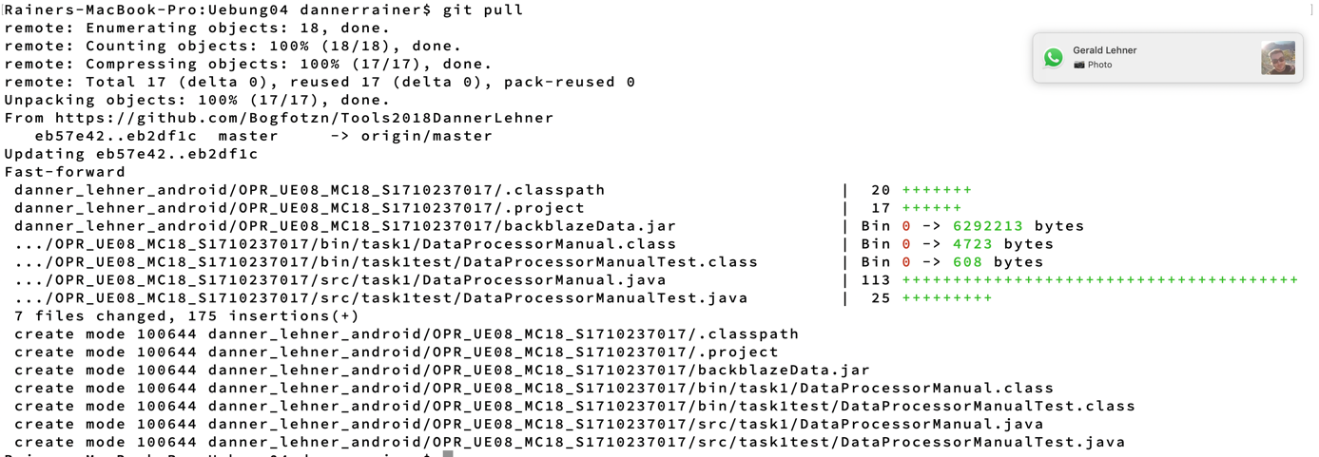

Member2: git pull







Member1: DO NOT COMMIT, only pull. What is the problem and how can you

solve it?

Problem is: Your local changes to the following files would be overwritten by merge

Solve by commiting changes then pulling then manually resolve the conflict, add, commit and push again.

Conflict occur when changes to e.g. the same method occur.

What is the status of each local repo? Are there any differences between the

members? Why/ Why not?

Repos are identical because all conflicts were resolved, and all updates pushed and pulled.

How can you let git know to which branch to push to hen only using the „git push“ command without

any further parameters?  
By using git push -u <remote> <branch> the upstream can be set and following git push will use the set upstream for this branch.

− Why is it important to pull before each push?  
To get the latest updates from the server.